**Aim:** To Automate the Email.

**Objectives:** Understand how to Automate Email using the Email Actions.

**Tools Used:** Automation anywhere tools

**Concept:**

Use the Email Connect action to establish a connection.

Use the Send Email action to automate email sending.

Use the Email Reply action to automate replying to emails.

Use the Email Disconnect action to close the session.

Use Browser Open and Mouse Click actions to open Gmail and download attachments.

**Problem Statement:**

1. Automate send Email.
2. Automate the Email to reply a mail.
3. Automate the Email to download the attachment.

**Solution:**

**Problem 1:**

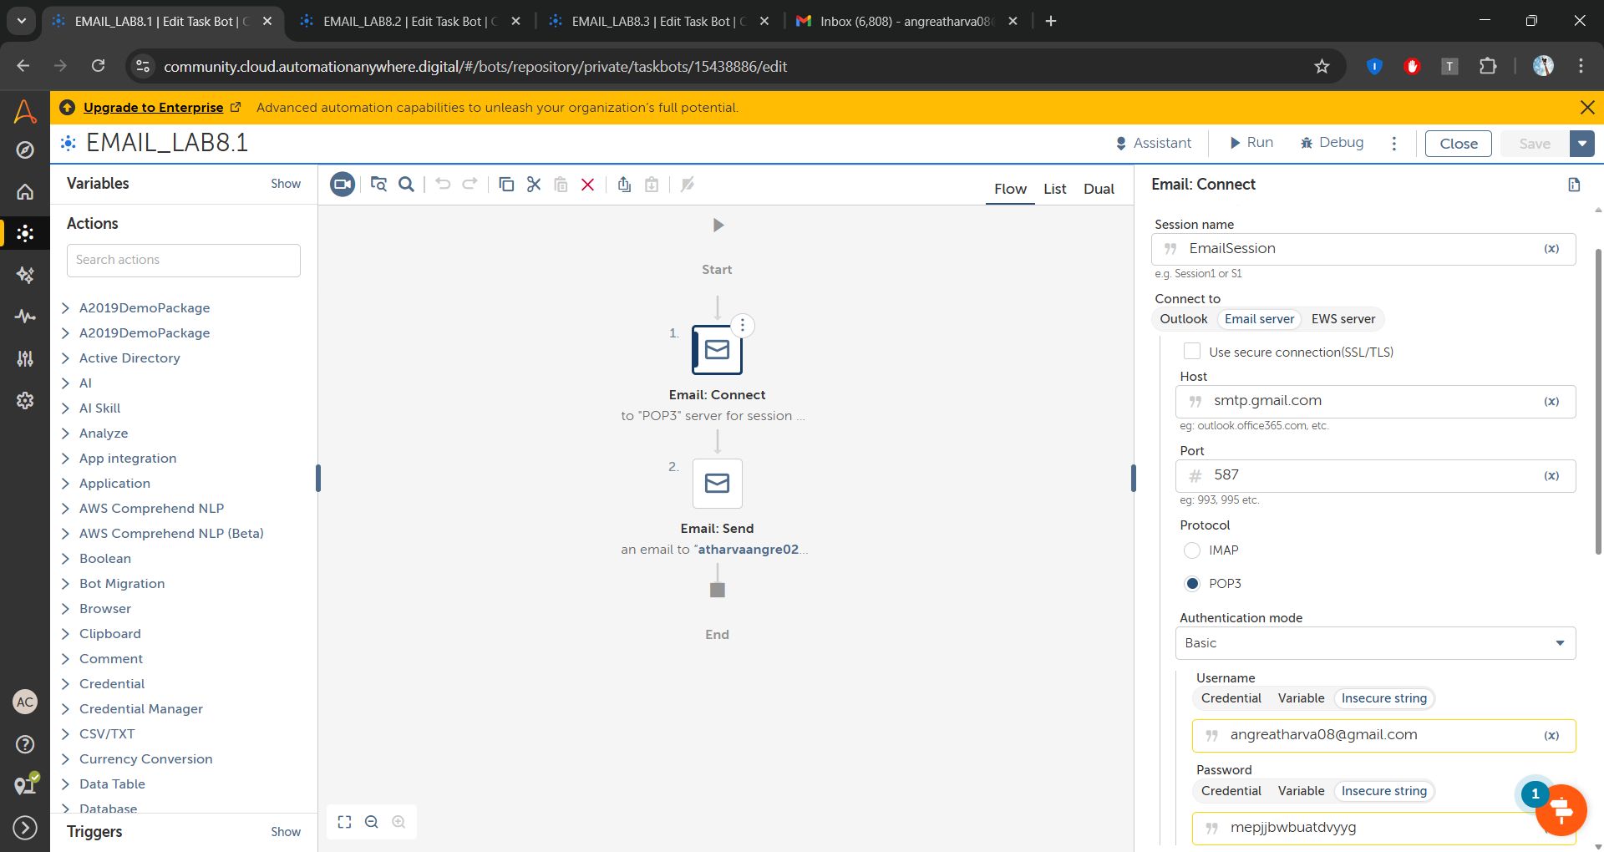

**Step 1: Use the Email Connect action**

Use smtp.gmail.com as host name and 587 as port and protocol as POP3.

In the gmail add the gmail ID and password add the APP PASSWORD.



**Step 2: Use the Send Email Action to send the email.  
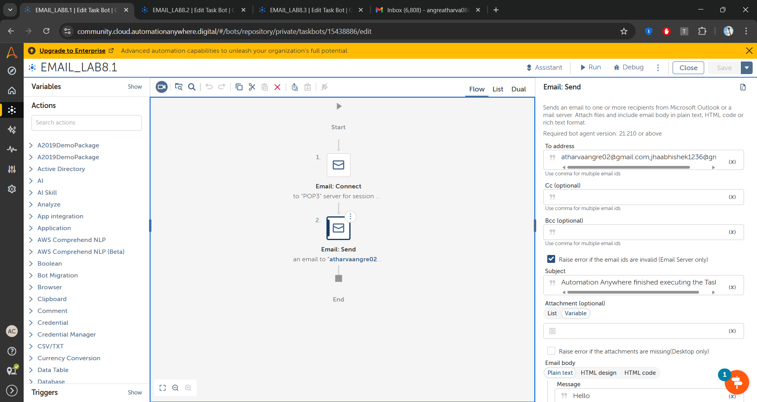**

**Problem 2** 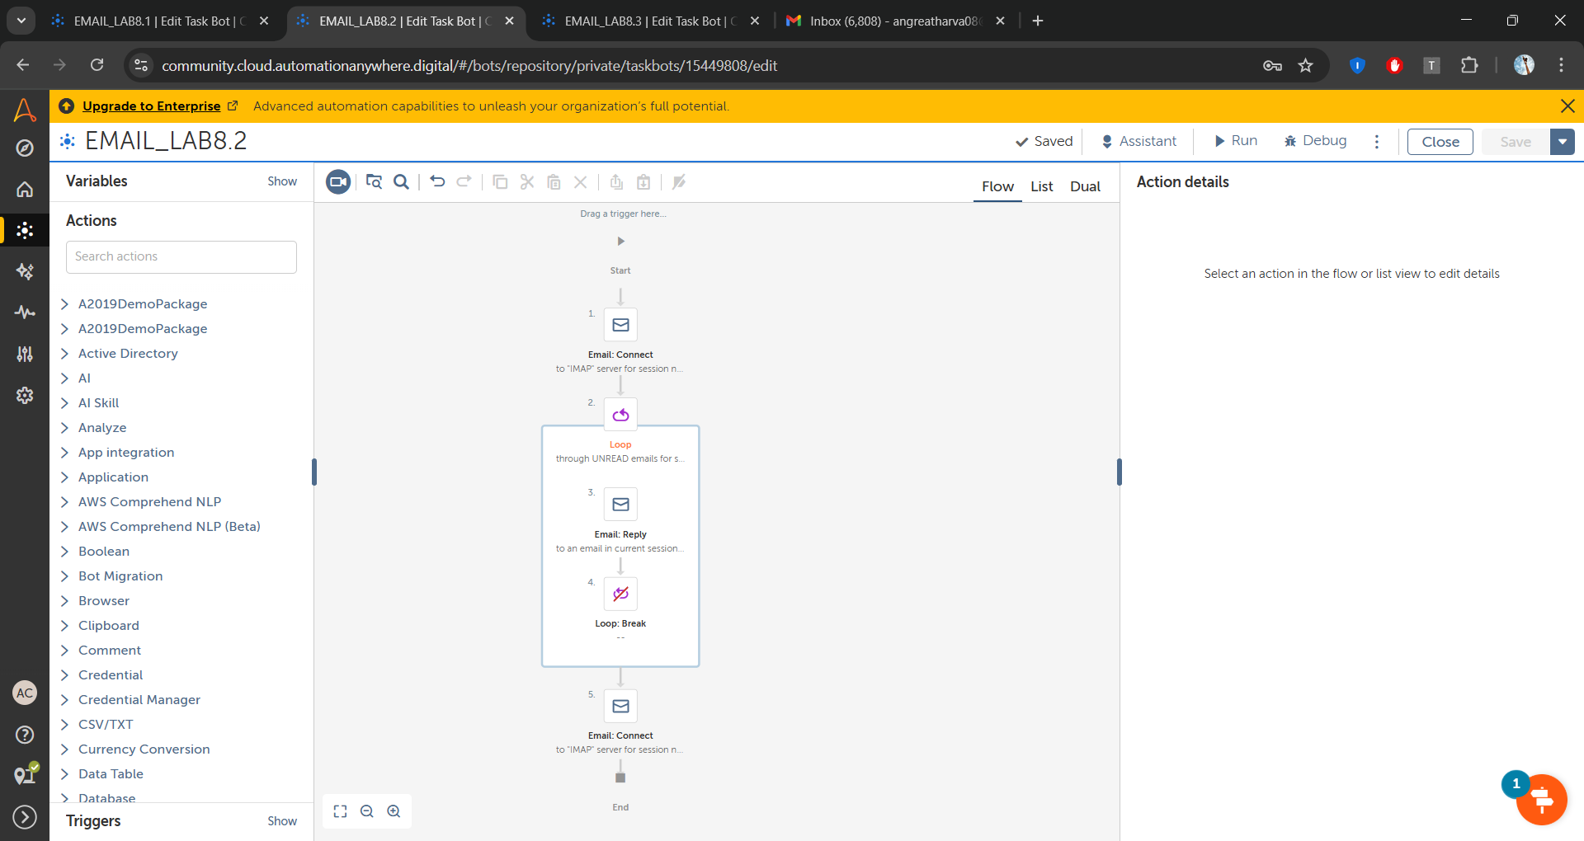

**Step 1:**

**Step 1: Use the Email Connect action**

Use imap.gmail.com as host name and 993 as port and protocol as IMAP.

In the gmail add the gmail ID and password add the APP PASSWORD

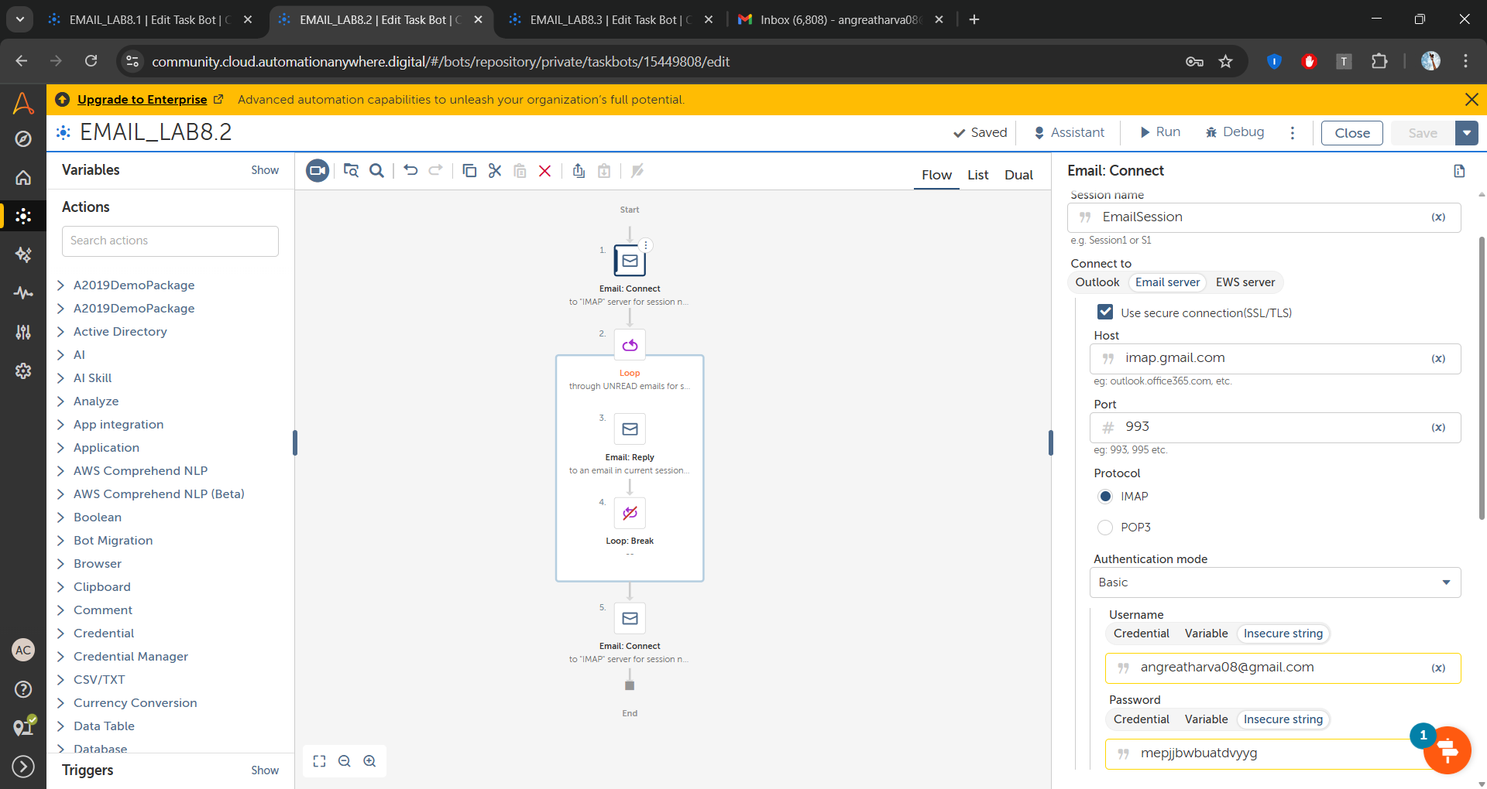

**Step 2: Use the loop to iterate through mails in the inbox**

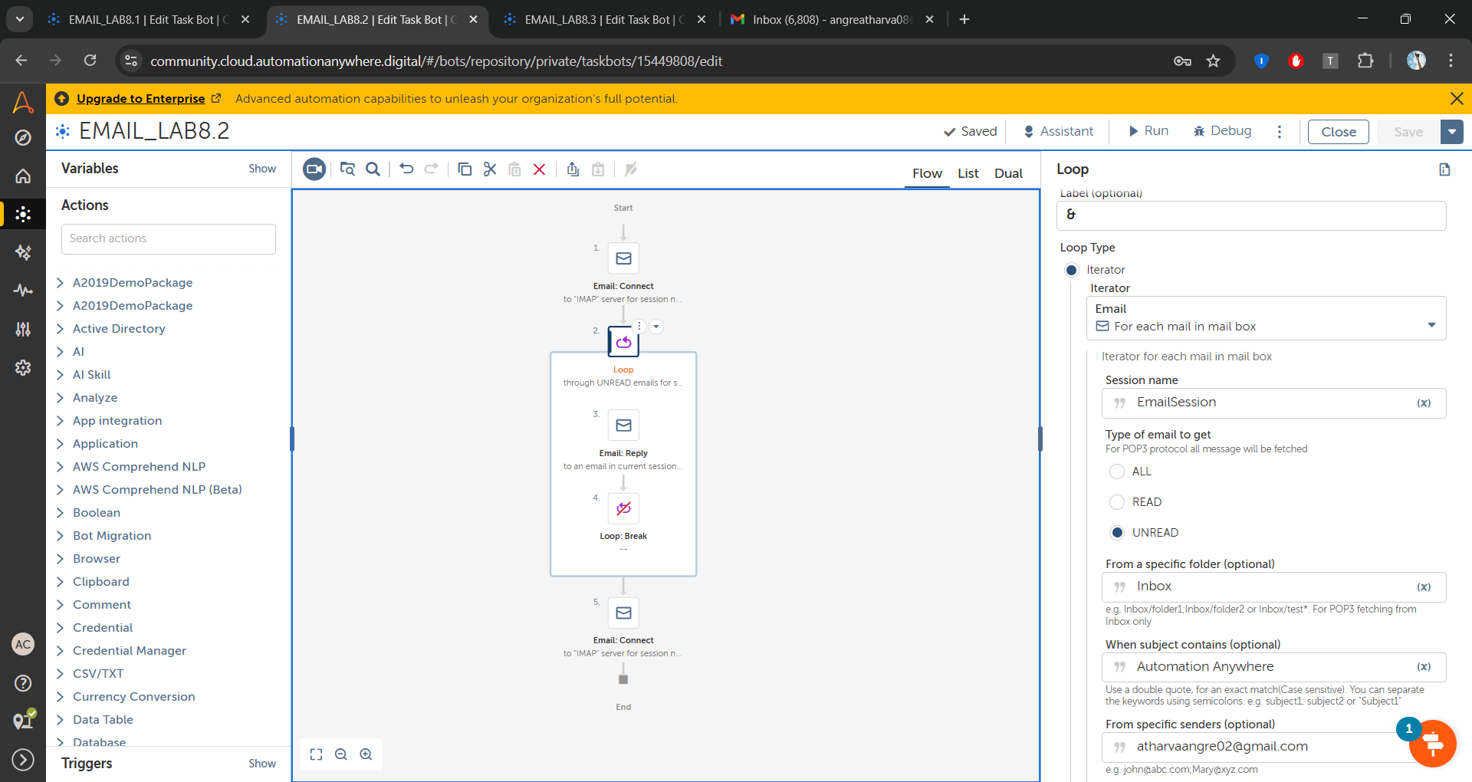

**Step 3: Use the Email Reply action to reply the mail.**

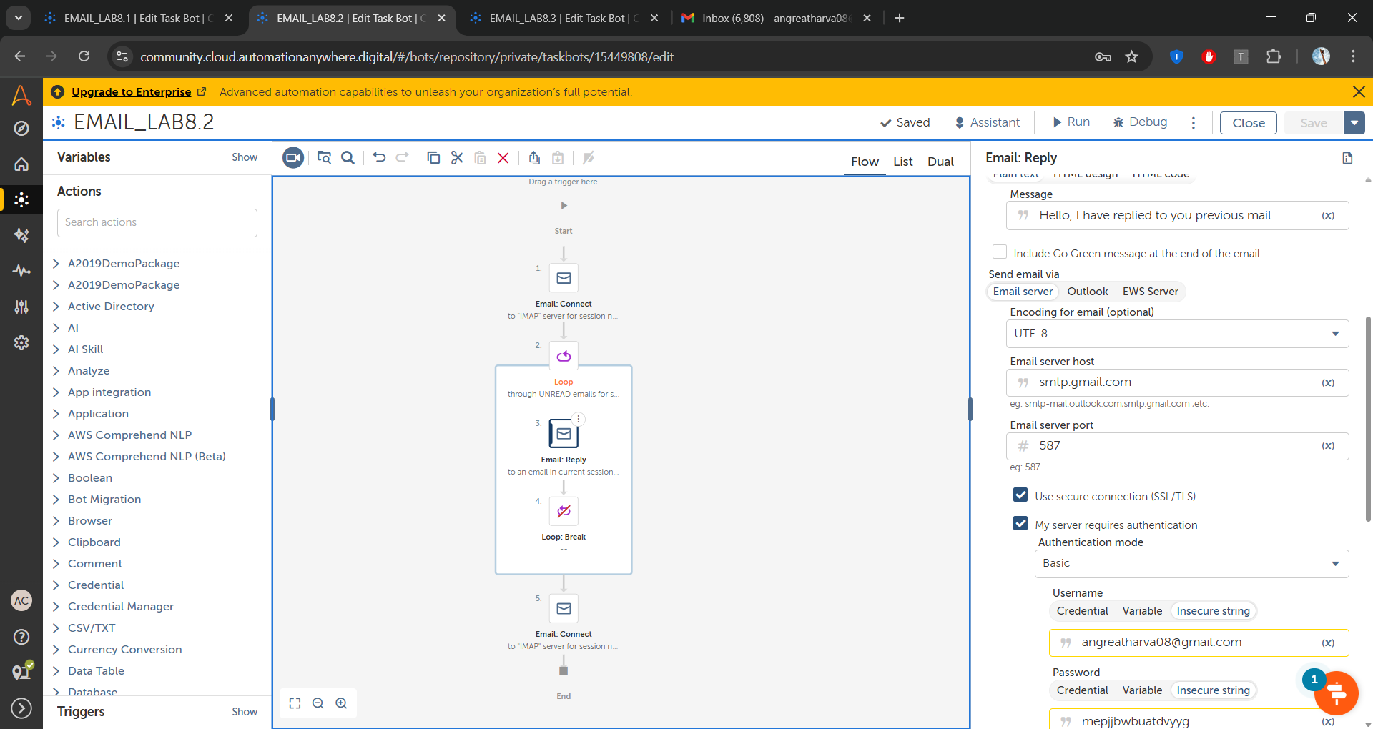

**Step 4: Break the loop**

**Step 5: Disconnect the Email Session use Email Disconnect action.**

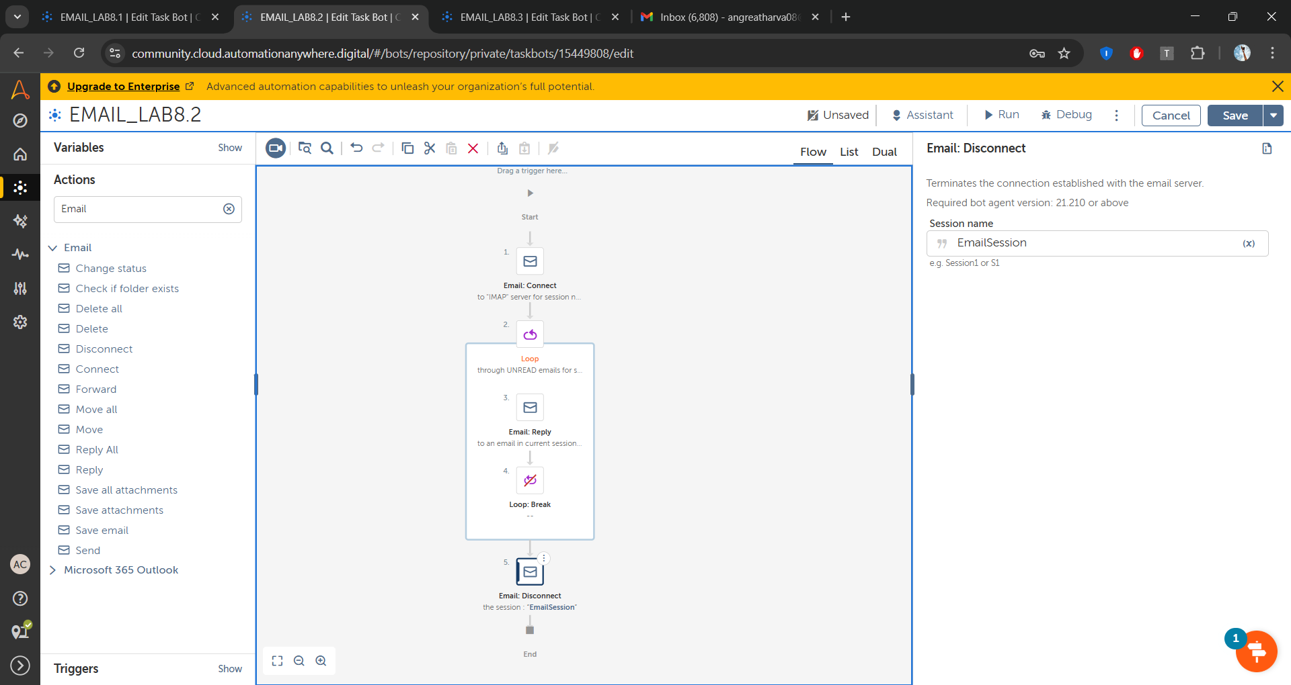

**Problem 3**

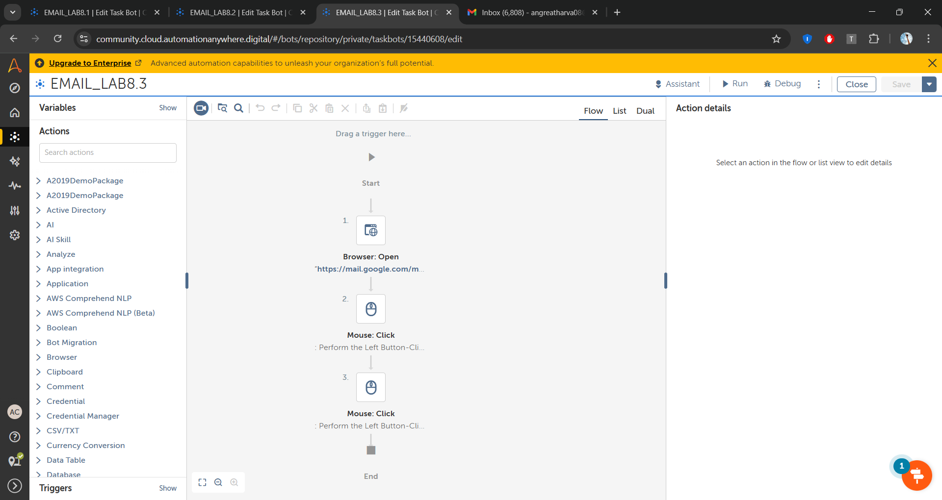

**Step 1: Use the Browser Open action to open gmail in the Browser.**

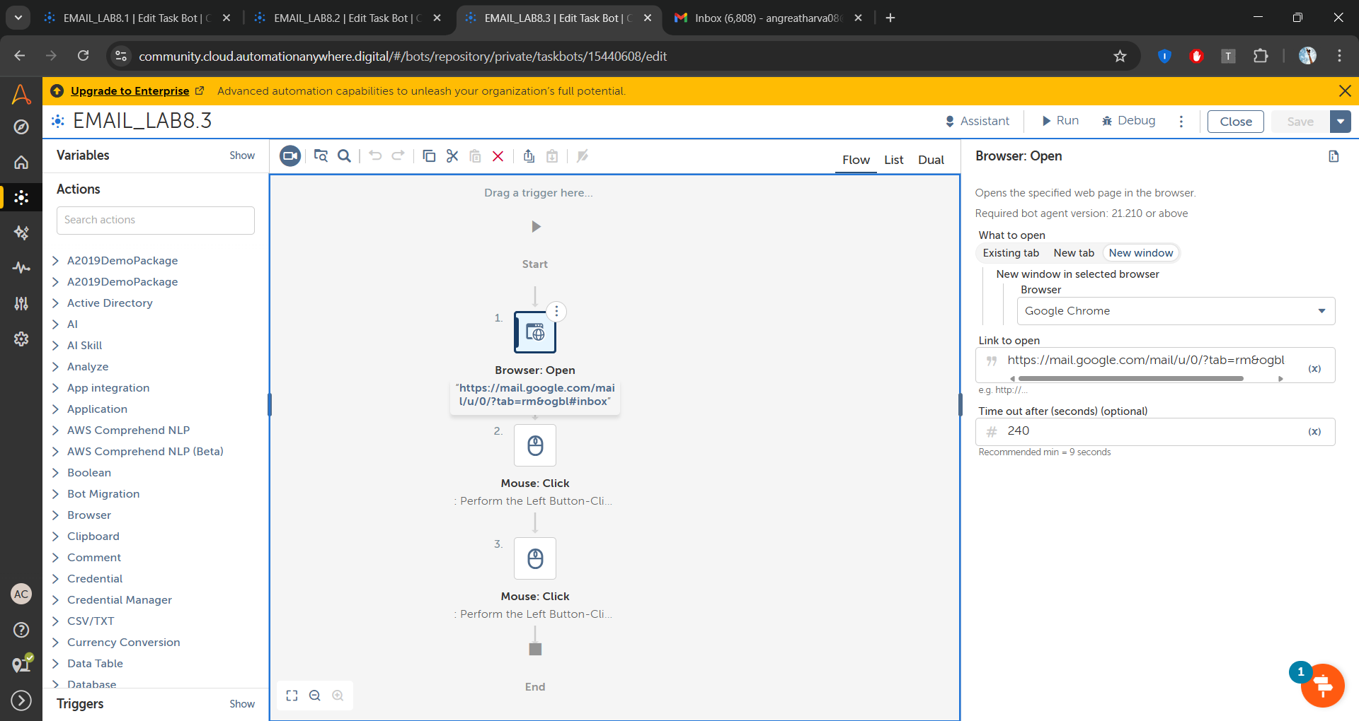

**Step 2: Use the mouse click to open the mail having the attachments  
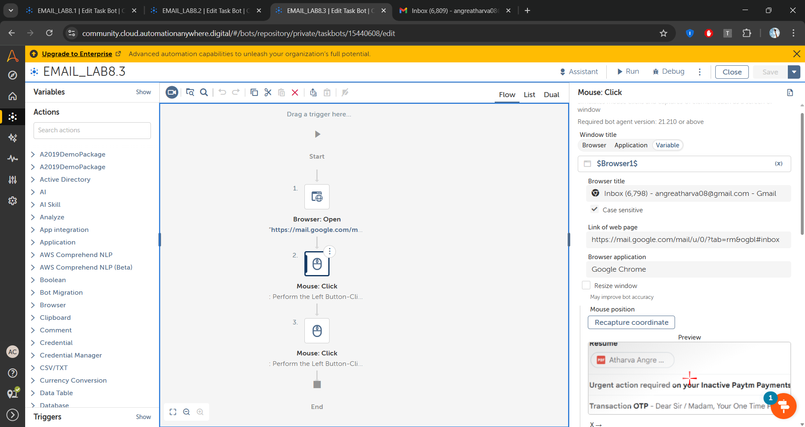  
Step 3: Click on the download button using the mouse click**

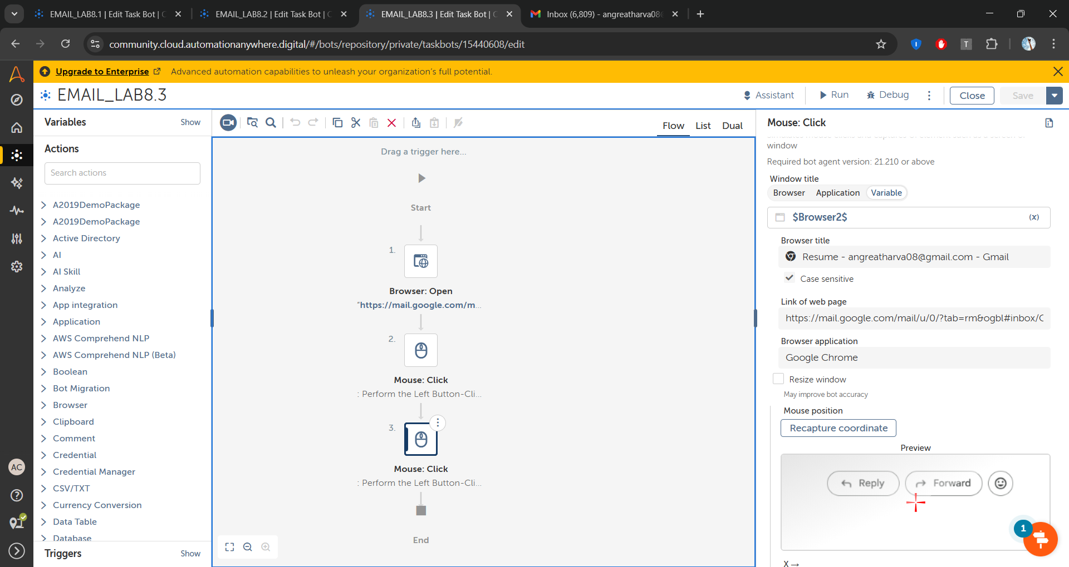

**Observation:**

Automating emails using Automation Anywhere makes the process faster and more efficient. The Email Connect action helps establish a secure connection using SMTP or IMAP. Sending and replying to emails becomes seamless with the Send Email and Email Reply actions. Iterating through inbox emails ensures proper mail handling, and disconnecting the session prevents unnecessary connections. For attachments, opening Gmail in a browser and using mouse clicks allows easy downloading.